**Token Weighted Rankings**

Concept Note

Team Startereum

*This concept note explains a key feature of the Startereum project, namely Token Weighted Rankings. It is not a whitepaper and makes no claims to explain or defend the total value proposition of the project. It assumes some familiarity with the crypto-token ecosystem. - TS.*

**Introduction**

Since its inception almost a decade ago, different people have been inspired by Bitcoin in different ways. Some see the promise of riches without end, others see an escape from governmental control, and still others a new and paradigmatic architecture of information and value through which to organize and design interaction. Team Startereum is in this last category.

Our springpoint is the unique and recursive incentive architecture of Bitcoin: those who maintain the chain and give durable value to the token economy are themselves rewarded in tokens. This aspect of the bitcoin blockchain has also been described as a *systemic reward*, and it is new and inspirational for a range of crypto-economic projects that seek to bring this logic of the protocol layer now to the application layer. We hope to be among them.

No centralized authority is required in the bitcoin blockchain to do the work of ledger managers, as this is now being done automatically, computationally, and with a transparent incentive structure that safeguards against bad actors seeking to corrupt or interrupt the maintenance of the ledger. This same logic should be applicable to many other areas of human activity, particularly those dealing with finance and decision-making. We are interested in the area of capital allocation and investment selection, and aim to apply a token-incented approach to the design and operation of an investment advisory mechanism.

If the core problem of Bitcoin was the maintenance of a ledger, the core problem in early stage investing is the establishment of preference, or ranking. How do you compare one proposition in relation to another so that you know which is the better one? On what dimensionality or set of dimensions? How much time and money should best be spent learning about each? How do you establish objective criteria for your decisioning framework? How can you establish a practice, protocol or platform, whereby several people can apply these methods and standards in a shared and intersubjective way.

In an age of platforms, investing itself has remained stubbornly old school. A small number of trusted intermediaries work closely together and rely upon their own professional networks to make deals flow.

We believe token incentives can change this way of working for the benefit of teams and investors alike. Along the way, we believe that we can make investment opportunities available to a larger number of retail investors than has been possible before. We can filter and sort and identify the most promising opportunities openly, publicly, while also making these deals available to our community.

At the heart of our approach is a deceptively simple game that we call Token Weighted Ranking (TWR). These are simple A/B tests wherein players throw down tokens against their choice. At the end of the game one project will be supported with more tokens than the other, and it will therefore be ranked above the other. These games can go on many times a day in many regions of the world until all the items have been ranked against one another. When a new project shows up it can be quickly ranked and sorted against the existing lineup.

In the remainder of this paper we will explain how TWRs work, how they can be protected against attack, and what kinds of input or felicity conditions are required for them to produce meaningful rankings.

**An Example of a TWR**

Consider a comparison game called Team-Dream Fit. Here a team’s members and overall competence in relation to its stated objectives is being compared to the *fit* of another competing team.

Players of this game are shown text excerpts for Team A on the left and text excerpts for Team B on the right. All proper nouns are de-identified, as for example Founder 1, Founder 2, Founder 3, University of X, ABC Corporation.

A player is asked to chose one team over the other.

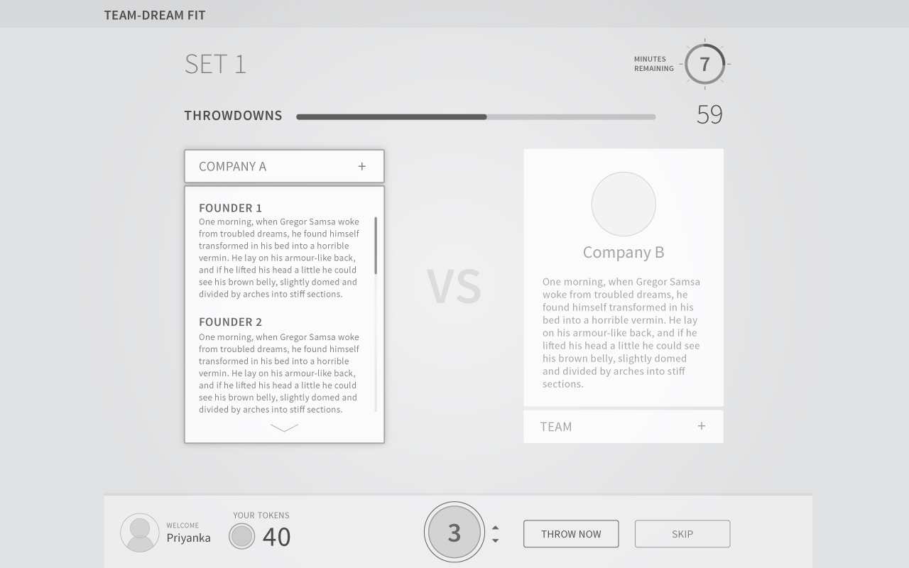

She is also able to view how many throwdowns (stakes) have already been made, but not how many to which team.

She is on a timer to make a throwdown or else pass through to the next game.

She places 3 tokens on team B.

The game ends in 10 minutes, at which point the results are announced: 27 tokens on Team A versus 34 tokens on Team B.

Our player will receive 27/34*3 = 2.38 tokens as her winnings.

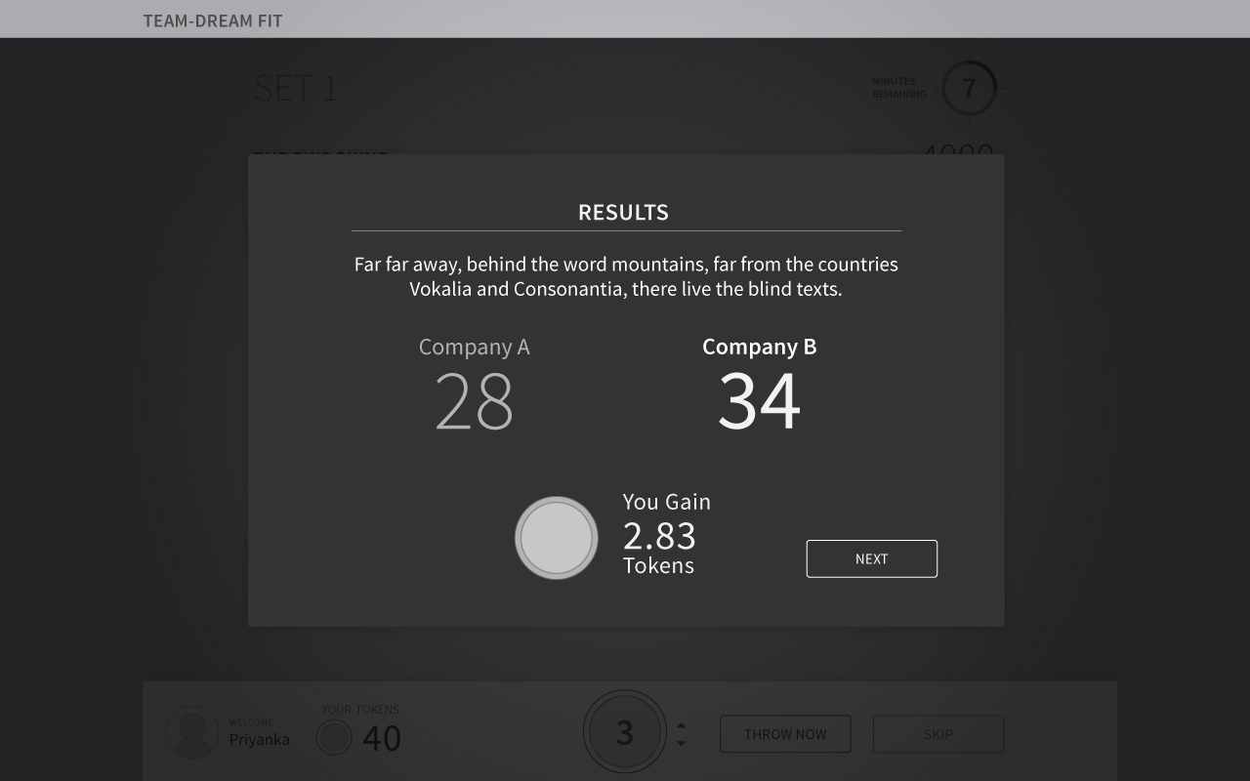

In practice, of course, the house may keep a fraction of those winnings, resulting in a slightly reduced winnings.

As a result of this game, however, the platform is now aware that B > A, and can use this information to further sort both teams along a ranked hierarchy of Team-Dream Fit.

This process goes on for many other games until the entire series is ranked in order along multiple dimensionalities.

**Token Metrics Help Rank a Project**

Consider a new project P which must be ranked against an existing series of 100 projects. What are the fewest number of comparisons through which it can discover its rank? Let us begin inductively, ranking it first against project number 50. It either wins or loses, in which case it must go up against projects 25 or 75, respectively. Let us assume it won and then wins again. We now set it up against project number 12. It loses! Within 3 challenges we have therefore been able to establish its rank to the nearest octile, somewhere between rank 12 and 25. If a more precise rank is sought, up to another six games may be required.

TWR is not only an interface or game design, but also a framework through which items can be comparatively ranked. As implied by the name we have chosen for this device, we propose to use the relative proportion of winning tokens to losing tokens to help weight the ranking of the item so evaluated.

Consider again our new project P, slated to go up against our existing project number 50. The TWR is decided in favor of project P by 66 tokens to 33 or 200%. A default algorithm design might now slate project P to go up against project number 25. But its strong showing could weight this choice upwards, say to project 17. The differential of the token weights in TWR game outcomes guides our game creation algorithm as to how many slots above or below the current throwdown the team should next be slotted for challenge.

But what of project number 50? It performed so poorly against a contender that perhaps its slot must now be reevaluated? Using the logic of classical physics where two bodies of momentum m1v1 and m2v2 collide with one another yielding new velocities, we might assume that project 50 must now go up against a lower ranked team, for example project number 63. If it wins it may well bounce back up into the 50s or nearabouts.

How many times shall we allow such ‘momentum-based’ disturbances to reorder our existing ranking? In principle, so long as there are players to play and rank teams, this entropic oscillation could go on forever. But we have operational limits because our rankings are conducted by human minds who must be capable of seeing meaningful distinctions between propositions to be able to reliably rank them against one another. This might mean that we arbitrarily truncate such momentum driven challenges at the third iteration, for example, or at a point where the token weightages fall within 10% of one another.

Is token weighting a meaningful path to walk down? If you compare P vs. 50, does this really convey significant information about 49, 63, 75, 25, and 17, which we are now implicitly involving in the ranking exercise? Arguably yes, because a ranking, to be meaningful, must be graded and continuous -- and continuously updated to reflect current market reality. Far better, perhaps, to be continuously testing and validating a ranking than to award it and then allow it to fester with long intervals between challenges.

Furthermore, when comparing projects that are within a half decile of one another we may not be able to conclusively find in favor of one or another project because they are too close to call. This might mean that we must compare them with projects a decile up or down and use token weighting to establish their relative rank -- which will only be approximations because really the immediate comparisons will yield a wash.

While we may launch with a provisional ranking algorithm with or without token weighting, it will likely have to be tweaked and optimized over time to contend with multiple operational parameters including number of projects, number of players, number of games, average tokens allocated per game, numbers of new projects coming in and even the longevity of projects or any salient changes to project details that may arise since they were last ranked.

One challenge we will likely confront in maintaining our ranking is the frequency with which items oscillate around their mean ranking. Like electrons in their orbitals, we may then only be estimating to some statistical approximation the actual rankings of projects. This may be accurate, but it may also decrease the confidence audiences have in our ranked output.

On the other hand, too many games with nothing to choose between contenders and players may suffer burnout. This may also limit the accuracy with which we can determinatively rank projects against one another, particularly once we get up to the middling and upper three digits.

Such questions continue to be explored by the core team in dialogue with experts in combinatorial math, statistics and solid state systems alongside computer science and human cognition. The provisional resolution to these questions in the form of a live and functioning algorithm may have to await the actual implementation of TWR on the Startereum platform.

**The Relevance of TWR to the Investment Case**

‘I’ll know it when I see it.’ This may be the most unhelpful and common phrase employed by a decision-maker when queried about the process of making their decision.

One might say that in all cases where judgement is to be employed in reducing a set to a more desirable or higher value subset, complex curatorial decisions are being made in realtime, which offset risk, achieve diversity and still, hopefully, maximize value and viability of the selection set.

It has been the hope of many that so-called Token Curated Registries might help create such a subset more swiftly, scalably, automatically. In our view, this will not be possible due to the curatorial, offsetting and arrangement function of any investment set.

What can happen, however, is that those decisions are well aided through more detailed and thorough-going investment inputs, as provided through a ranking of multiple decisioning dimensions.

One might also consider putting more and more pressure on the decision making committee to provide explanations as to why they are deviating from the investment advisory inputs emerging from the ranking mechanism.

Over time, moreover, one might be able to track whether the exercise of such judgement and deviation from the community ranking is resulting in an any alpha for the investment fund.

**Felicity Conditions for TWR**

* Capabilities and Motivations of the Player

If the player doesn’t understand the game or the information provided, their inputs are compromised. If they are playing for extrinsic reasons of any kind, their throwdowns may also be suspect.

* Meaningfulness of the Comparisons

*Do you like this AI team or this Biotech team?*

*Do you like this set of founders or that?*

*Do you like this security token or that utility token?*

Comparisons which are arbitrary or absurd are likely to grate the user. For engagement and meaningfulness the primary data should not be presented but rather hidden relationships between the dataset explored.

* Appropriateness of the Evidence Provided

If the information provided is unlike, it is unlikely to be evaluated objectively. For instance, poor grammar compared with strong composition. A short three line outline compared with entire paragraphs of text.

If the information is a pack of lies, the ranking will have absolutely no merit. It must therefore be vetted and verified before game play.

* Aligning Incentives of the Player to the Results

Players will only play so long before ennui sets in. They must enjoy extrinsic and intrinsic motivations to play. One important way to achieve this is to give them the opportunity to earn or buy stakes in the winning teams that emerge from the collaborative efforts of the crowd.

* Meaningful Closure of the Contest

*Team Blue is best.*

*Tokenization of Transportation has won.*

*Walnut Asset Backed token is higher.*

Whether you win or lose stakes in the game, you want to feel meaning and closure from the result. One way that can be ensured is through a discussion board where participants talk smack about the team entries.

* Limit Conditions on the Stakes

If too few throwdowns occur the result may be in question.

If players can throwdown any size of stakes, they may skew the result excessively.

While it is in the interests of the platform to let games optimize to a relatively high number of losing stakes, this interest must be offset against the need to have fair, meaningful results to games played.

* Limit Conditions on the Players

Players should not be allowed to play more games than they might enjoy playing. Nor should they be allowed to choose which game they play, as this may allow cheating or motivated gaming.

* Dynamic Evolution of the Game

In important and high value contests, the platform may allow the game to drag out, have higher limits and even enjoy open disclosure of ongoing game status, all in the interests of engagement and appropriate final outcome.

* Attack Prevention

TWRs must be played on demand, without the option to skip the game presented, with key team information de-identified, without teams being made aware that their project is under review, among a large distributed global audience.

**Providing Systemic Rewards**

So far we have made clear that players can win and lose tokens from one another by throwing down against the option they think is stronger. This is a relative and local reward, not a systemic one. That is to say, the winners and losers and holders of tokens are not rewarded in proportion to the increase in systemic value that their participation brings about.

In an ideal world one might seek to make investments into the top ranked projects on behalf of all the token holders and distribute the long term gains originating from these investments to each and every token holder. In practice, however, current regulatory requirements would prevent such a scheme from being implemented because it would very much resemble a security token architecture.

We might therefore have to be satisfied with making special awards or rewards to high performing players who appear on the platform leaderboard. This may take the form of direct airdrops where these have been negotiated with projects under rank or else participation in a secondary instrument of some kind which actively invests in high ranking projects.

**TWR in relation to other Token Incented Algorithms**

Our project, Startereum, is a subset of collective intelligence platforms which use tokens to incentivize users to do human work of a kind that cannot be approximated through AI [cite].

TWR fits within an emerging family of token-incented algorithms which operate at the application layer rather than the protocol layer. In this section we discuss how they are similar and different from other existing types known at this time. We also discuss why TWR may be a better fit for investment decisioning case as compared to these other types.

* Token Curated Registries

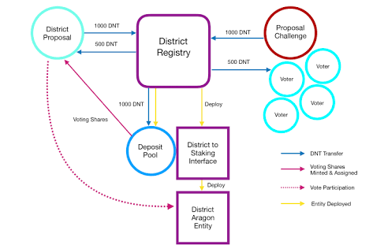

Token curated registries are an elegant mechanism for creating an elite subset from a given set through the active collaboration of the very participants who seek to become members of that set. A small fee is paid to be processed by a platform, upon which verifiers are observing interactions. The fee stakes the claim of a participant to be allowed entry into the elite subset. If a challenger contests the claim verifiers come into play to adjudge between them. If the challenge is deemed stronger, the entrant is denied. If there is no challenge, or if the challenge is deemed the weaker, the entrant is accepted.

Whereas TCRs are likely to be very useful for some set making challenges, such as the best hangouts in seattle, the best restaurants for a romantic date and so forth, we are doubtful of its applicability to the investment use case. In our view, investment decisioning is not merely a question of eligibility, *but also of relative merit*. Therefore we must know ranks.

To use TCRs directly means, in some sense, to completely obviate the need for human decision making. Investment portfolios are indeed curations, but they are of an older aesthetic and compositional variety -- they hedge countertrend risk and risk-return ratios in idiosyncratic ways that are still difficult to replicate through collective intelligence approaches. We are therefore sceptical of attempts to completely obviate the role of investment professionals with skin in the game. Rather, we believe we should provide ranked evaluations of multiple dimensions of excellence, which may then inform investment decisions, without necessarily making them.

* Prediction Markets

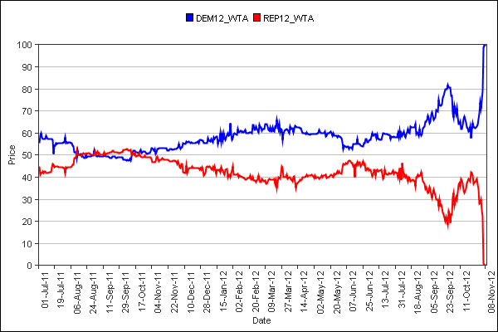

Prediction markets have existed long before the advent of crypto-tokens. Like the TWR game we have proposed, there are multiple players involved in staking against one another, but for an outcome which is external to the game. That is, either a celebrity will wed before she gives birth or not. Either the right wing comes to power or it doesn’t. For our larger purpose, namely to discover the strongest upcoming token projects, it makes sense to design the game based on the actual fundamentals of the proposal, rather than against the future performance of the token.

Tokens have improved the working of prediction markets, or have even possibly allowed them to operate at even larger scales, more transparently. Prediction markets typically require an oracle to alert a smart contract as to external event that has or has not taken place. Accordingly the tokens in escrow may be released to the player who has participated in the market. Moreover, the cumulative evidence of multiple individual wagers reflects a kind of public consensus about the perceived likelihood of an event, which represents as it were a new good, which may further be rented, sold or otherwise acted upon to create new value. Augur may be the paradigmatic case of a generalized prediction market.

In the case of early stage funding of token projects, however, it is difficult to establish the external event which is being wagered. Future sales and growth in value may or may not arise, and the benefits of such wagers cannot be immediately actioned as signal, nor used as seed capital by projects. Some projects which have nevertheless attempted to approximate such wagers are Cindicator and Wings.

* Curation Markets

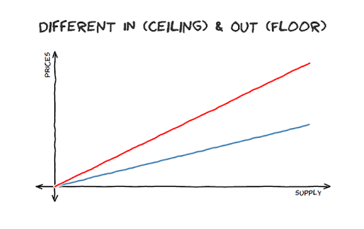

Curation markets describe a series of bounded entry and exit conditions into a proposition which is expected to increase in value over time. In effect the early entrant is providing investment as well as an investment signal to others in the ecosystem about the potential of the given proposition, which may, for example, be a token. As the proposition grows in value, however, the initial entrants are prevented from exiting at the new price, but must exit at a calulable lower price, thereby preventing or at least limiting pump-and-dump churns.

One might try to argue that curation markets are an elegant solution that provides market signalling with far lower friction than our own proposition, the TWR. However, one might counter that that this signal has everything to do with future market expectations, in other words secondary signals rather than primary signals which have to do with the fundamentals of the proposition. Our approach deals specifically with the fundamentals in every single instance of game play.

The more substantial divergence between curation markets and the TWR scenario is that we are dealing in prelaunch and prelist tokens. This means that there is no existing mark to market index where we can discover them or evaluate their performance. This is the very good that we create through the TWR.

**References**

District0x. (2017, August 14). District Proposal Spotlight - 1Hive, An interview with Luke Duncan of Hive Commons. Retrieved from<https://blog.district0x.io/district-proposal-spotlight-1hive-283957f57967>

Feeny, E. (2018, February 6). POE: An Economic Tool for Crowdsourcing Truth. Using tokenized incentives to value the world’s digital creative asset. Retrieved from<https://blog.po.et/poe-an-economic-tool-for-crowdsourcing-truth-3b085e4bf7cc?gi=a8342ef06649>

Goldin, M. (2017, September 14). Token-Curated Registries 1.0. Retrieved from<https://medium.com/@ilovebagels/token-curated-registries-1-0-61a232f8dac7>

Lena and Oxana (2017, December 22). Collective intelligence platforms. Telling the difference. Retrieved from<https://hackernoon.com/collective-intelligence-platforms-telling-the-difference-62f3e50cd57f>

Rouviere, D. S. (2017, May 22). Introducing Curation Markets: Trade Popularity of Memes & Information (with code). Retrieved from<https://medium.com/@simondlr/introducing-curation-markets-trade-popularity-of-memes-information-with-code-70bf6fed9881>

Rouviere, D. S. (2017, November 21). Tokens 2.0: Curved Token Bonding in Curation Markets. Retrieved from<https://medium.com/@simondlr/tokens-2-0-curved-token-bonding-in-curation-markets-1764a2e0bee5>

Rouviere, D. S. (2017, April 10. Edited, 2017, May 22). Curation Markets. Retrieved from<https://docs.google.com/document/d/1VNkBjjGhcZUV9CyC0ccWYbqeOoVKT2maqX0rK3yXB20/edit>